## Enterprise Wikis and Social Networking

**Lab Time:** 60 minutes

**Lab Folder**: C:\Student\Labs\EnterpriseWikisSocial

**Lab Overview:** In this lab you will be working with the social aspects of SharePoint 2010. First, you will create an Enterprise wiki site collection which can be used as a knowledgebase for the company. Then you will define terms and term set for the site. You will use these terms to tag certain artifacts on the site (for example pages, documents etc.). You will then shift gears a bit and work on creating and enhancing a couple of user's My Sites.

### Exercise 1: Creating an Enterprise Wiki Site Collection

In this exercise, you will create an Enterprise Wiki Site Collection from Central Administration.

1. Open **SharePoint 2010 Central Administration**.
2. Click the **Create site collection** link under the **Application Management**. Use the following information to create a new site collection:

**Web Application:** http://intranet.wingtip.com

**Title:** Wingtip KM.

**Website address:** http://intranet.wingtip.com/Sites/entwiki

**Template Selection:** Publishing » Enterprise Wiki

**Primary Site Collection Administrator:** WINGTIP\administrator

1. Click the **OK** button to start the Site Collection creation process.
2. Once the Site Collection is created, click on the link that is presented. This should navigate you to the Enterprise Wiki Site Collection.

This Enterprise Wiki Site Collection will serve as a place for knowledge sharing in the Enterprise.

In this exercise you created an enterprise wiki site collection

### Exercise 2: Creating a Term Set

A **Term Set** is a collection of related terms and a **term** is a word or a phrase that can be associated with an item. In this exercise, you will be creating a collection of terms within a Term Set.

1. The Term Store Management System is accessed from the Site Settings. Using the ribbon select **Site Actions » Site Settings**.
2. Select **Site Administration »** **Term store management**. The Term Store Management Tool will open.
3. In the left navigation pane, click and expand the **Site Collection** node, you should see the **Wiki Categories** group. You will create your Term Set underneath the Wiki Categories group.
4. Click the **Wiki Categories**. Click the arrow that appears to the right of **Wiki Categories**.
5. From the drop down menu that appears, click **Create Term**.

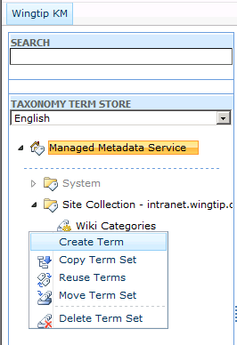

1. For the new term, type in **Toys**.
2. Now click on the arrow right beside the **Toys** and from the drop down, click on **Create Term** once again. You are now creating terms underneath the **Toys** group.
3. The first term is going to be **Bikes**, press <Enter> to go to create the next term; next term is **Cars**; and the final term **Board Games**.
4. Click back on the **Wiki Categories** drop down and click on **Create Term**. You are now creating a peer term group to **Toys**.
5. Name the new group **Regions**. Underneath Regions, create the following terms: **North America**, **Australia**, **Europe**, **Asia**. The Term Set is now created.

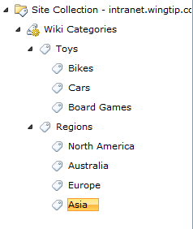

In this exercise you created a small and simple Term Set.

### Exercise 3: Working with Terms, Tags, Keywords and Ratings in the Enterprise Wiki Site

In this exercise, you will create new Wiki pages and you will link the Wiki pages together. You will also work with terms, tags, keywords and ratings to categorize your Wiki pages.

1. The Term Store Management Tool is accessed from the Site Settings. Browse to the **http://intranet.wingtip.com/sites/entwiki** site.
2. Using the ribbon select **Site Actions » Site Settings »Site permissions** under **Users and Permissions**.
3. Click **Wingtip KM Members**, click **New** in the Toolbar.
4. In the **Grant Permissions** dialog box that appears, type in **domain users** and press **[Enter]**. It will resolve to **WINGTIP\domain users**. Click the **OK** button. All domain users have now been granted the contributor right to the Enterprise Wiki Site.

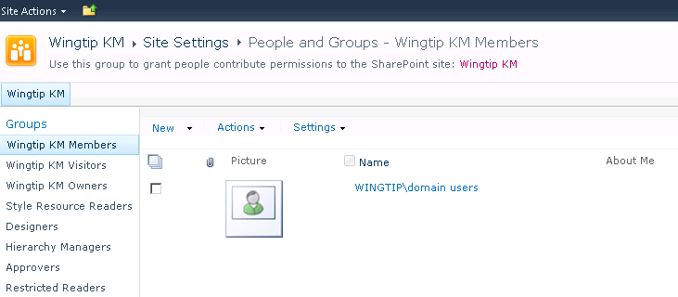

1. Go back to the **Wingtip KM** home page. Click on **Site Actions** **»** **View All Site Content**. In the **All Site Content** page click on the list **Reusable Content** list.
2. You will change the CopyrightReusable Content. Hover over **Copyright** and click on the drop down and bring up the drop down menu by clicking on the arrow. Click the **Edit Item** from the drop down menu.
3. In the **Reusable Content-Copyright** dialog box that appears, change the **Reusable Html** field: remove the word **Contoso** and type in **Wingtip**. Click on **Save**. You can now use the Reusable Content Copyright in any of the Wiki pages and it will show the content that is stored in the Copyright Reusable Html field.

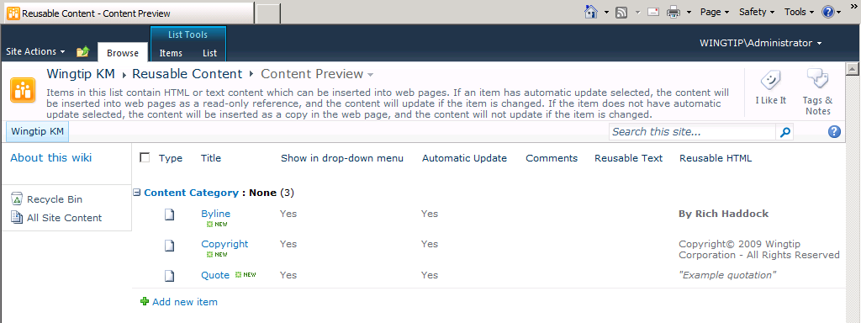

1. Navigate back to the home page of Wingtip KM. Log in as **Rob Walters**:
   1. Click the **WINGTIP\Administrator** selector in the upper right corner of the browser and select **Sign in as Different User**:

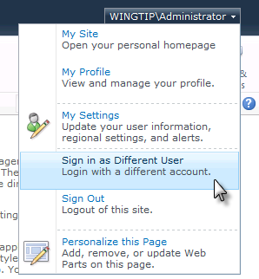

* 1. When prompted, login as **Rob**:

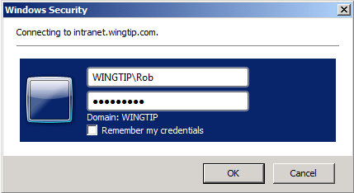

1. Rob, as a contributor to this site, will create some Wiki pages. First, Rob will upload a couple of documents. Click **Site Actions » View All Site Content**, click on the **Documents** document library, click on **Add new document** link.
2. From the **Upload Document** dialog box that comes up, click on **Upload Multiple Files**.

The **Upload Multiple Documents** window can be used to drag in files and folders. Anything that is dragged into this window will be uploaded to this library.

1. Upload the two spreadsheets in the [[LAB FILES]]\StarterFiles folder.
2. Click on **OK** in the **Upload Multiple Documents** dialog box and that should upload both of the documents to the **Documents** document library.

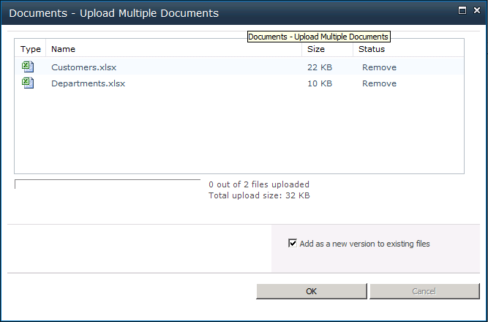

1. Navigate back to the home page of **Wingtip KM**.
2. Rob will now create a new Wiki page called **Cost**.
3. Using the ribbon select **Site Actions » New Page**.
4. In the **New Page** dialog box that comes up, type in **Cost**. Click the **Create** button. The new Wiki page should now be created and the cursor should be in the body of the page.
5. Type in the following in the Content: **We should think about moving a part of our manufacturing facility to China.**
6. You will now take advantage of the live style change preview to change the style of this text. Using the ribbon, under the **Editing Tools** contextual tab group select **Format Text » Markup Styles » Callout**.

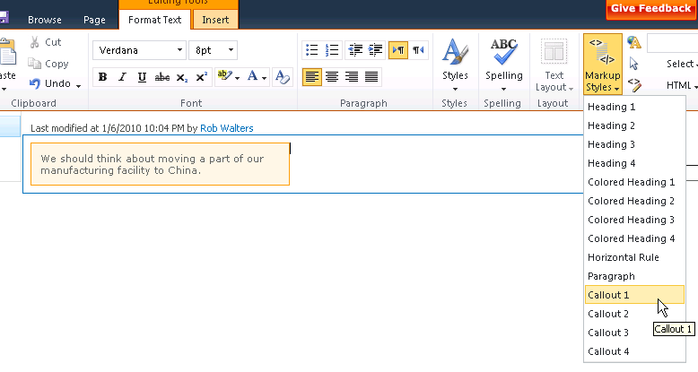

1. Now you will categorize page using the terms that were created earlier. Click the icon next to the **Categories** text box, the **Wiki Categories** dialog box should come up showing the terms and the Term Sets that were created earlier.
2. Click the **Toys** term, click on **Select** button, and click **OK**.

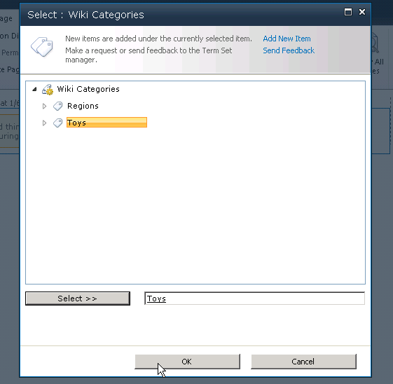

1. **Toys** should now appear in the **Categories** text box. Select **Page » Save & Close** button in the ribbon to save the page.
2. Navigate back to the home page of the site. Select **Page » Edit Page** icon in the ribbon, the page should now be in **Edit** mode. Select all the text in the body of the page and delete it.
3. Type in the following text in the Body of the page: **To continue our brand dominance, we need to come up with a better price point for our toys. Focus on cost reductions of our manufacturing process to start, also another option is to change our distributor in Africa. The value of the dollar has fallen but our profit margin from sales in Africa has not increased.**

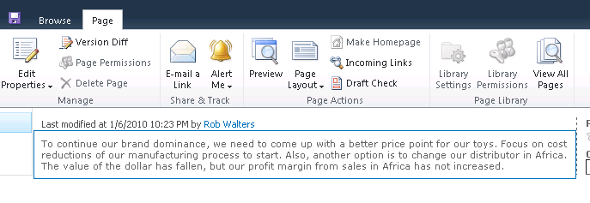

Now to branch off from the content on this page, you want additional content to be created to serve as your knowledge base. To make a word or a phrase into a link, you need to put in two brackets [[...]] on each side of the word or the phrase.

1. Click immediately before the word **cost** and type in two brackets. A popup box will appear displaying all the pages you can link to. Select **Cost** from the list and press **[ENTER]**.

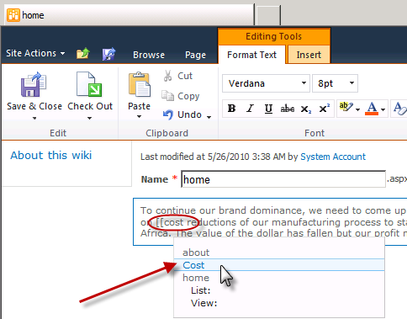

1. You also want to link **distributor in Africa** phrase, so put two brackets in the front and put two brackets at the end of that phrase.
2. Before saving this page, you also want to categorize this page. Click the text box for **Categories** and start typing in **No**. A **Suggestions** drop down should appear showing you **North America**. Select **North America**.

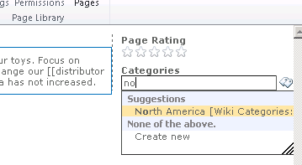

Type in **bi**. Suggestions drop down should appear showing **Bikes** as an option. Select **Bikes**.

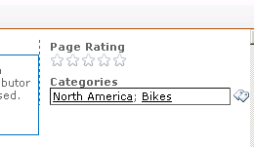

1. One more thing that you want to do on this page is to include copyright information. Go back to the text in the body of this page, add a few line breaks to the end of the content. Using the ribbon, under the **Editing Tools** contextual tab group select **Insert » Reusable Content » Copyright**. The copyright information should now be at the bottom of the page.

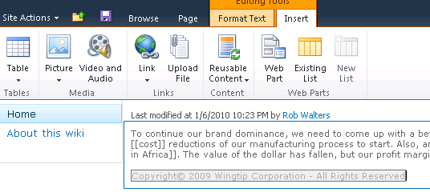

1. Save this page by clicking on the **Page » Save & Close**.
2. Notice that the word Cost is linked. Click on **Cost**, it will navigate you to the page **Cost** that you have created earlier.
3. Now navigate back to the Wingtip KM home page, the phrase **distributor in Africa** is also linked but it is a broken link, meaning it does not currently lead to any page. That page has not been created yet.

You will now simulate another user coming to this page and clicking on the distributor in Africa link to create the content for that page.

1. Log in to this page as **Ken Sanchez**.
2. When you are logged in as Ken Sanchez, click on the **distributor in Africa** link, it should show you a dialog box saying **The page does not currently exist and asking you, do you want to create it?** Click the **Create** button.
3. The **distributor in Africa** should now be created and be ready for you to insert content into.
4. Type in the following for the content of this page: **I have dealt with a distributor in Africa called We-Distribute-for-Less with great results. I will contact them with a quote.**
5. Highlight the text **We-Distribute-for-Less** and **bold** it.

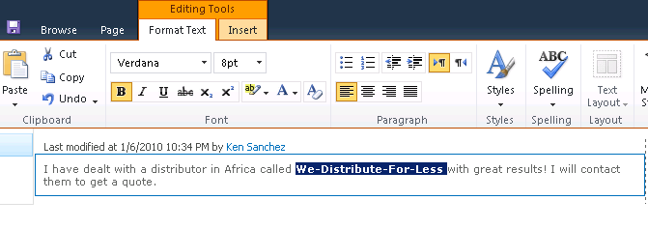

1. You now want to categorize this page. Click the icon next to the **Categories** text box to bring up the **Wiki Categories** dialog box. **Expand** the **Regions Term Set** group. The term **Africa** is not in the **Regions** group. Since that is what you want to use, you will now go ahead and create that term.
2. Click the **Regions** term, and then click on **Add New Item** on the top right of the dialog box. Type in the new term **Africa** and then click on the **Select** button to insert **Africa**, then click **OK**.

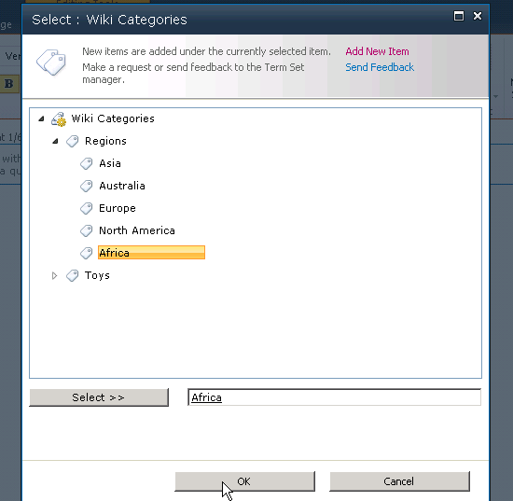

1. Save this page (**Page » Save & Close**). Navigate back to the home page of the site.
2. Sign back in as **Rob**. When Rob returns to this page and sees that the distributor in Africa link is no longer broken on the home page, he knows that someone has created content for it.
3. Click the **distributor in Africa** link to navigate to that page. Rob now sees the content that Ken had produced.

You have now created all the pages that you wanted to create. Close the browser window.

In this exercise you created some content and used the tagging, formatting and linking features of the Enterprise Wiki site collection.

### Exercise 4: Creating User Profiles

In this exercise, you will learn how to create user profiles in the User Profile Store. This is done by using the Central Administration of SharePoint.

1. Open **SharePoint 2010 Central Administration**.
2. Click **Manage service applications**. Click on the **User Profile Service Application** link. This will take you to the **User Profile Service Application** page.

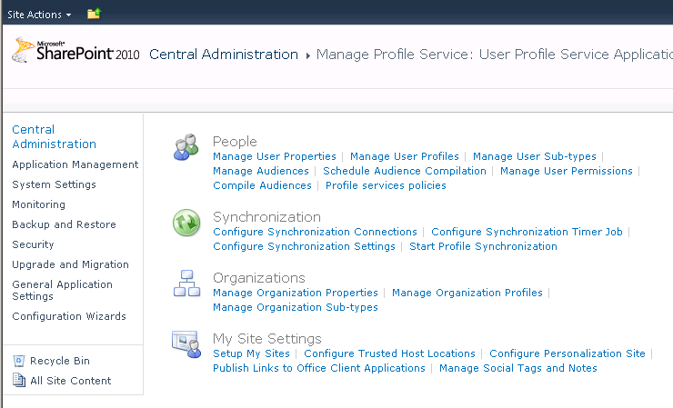

1. Click the **Manage User Profiles** link. Click the **New Profile** link. You will now create Ken’s profile. Type in the word **ken** and press **[Enter]** in the **Account Name** text box. Ken Sanchez should resolve automatically.
2. Go down to **Manager** text box and type in **Rob**, press **[Enter]**. Rob Walters should resolve. Click the **Save** **and** **Close** link up top. Ken’s profile has now been saved to the profile store.

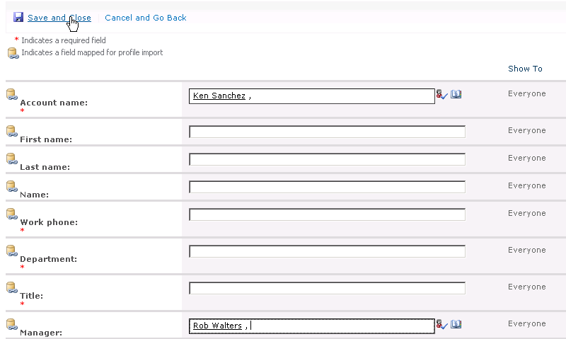

1. Using the same method, create **Michael Sullivan’s** profile with **Rob** as his manager.
2. Create another profile for **Rob Walters** with manager **Janice Galvin**.
3. Create the profile for **Janice Galvin** with no manager.

The total number of profiles now should be five.

In this exercise you created a few user profiles.

### Exercise 5: Creating and Setting Up a My Site

In this exercise, you will be creating and setting up a My Site for Rob Walters. Rob will edit his profile and other attributes of the My Site to provide as much content he can about himself and his interests.

1. Browse to the **http://intranet.wingtip.com/sites/entwiki** site.
2. Sign in as **Rob**.
3. Click **Rob Walters » My Profile** in the upper right corner of the page. This will take you to the Rob Walters profile page.

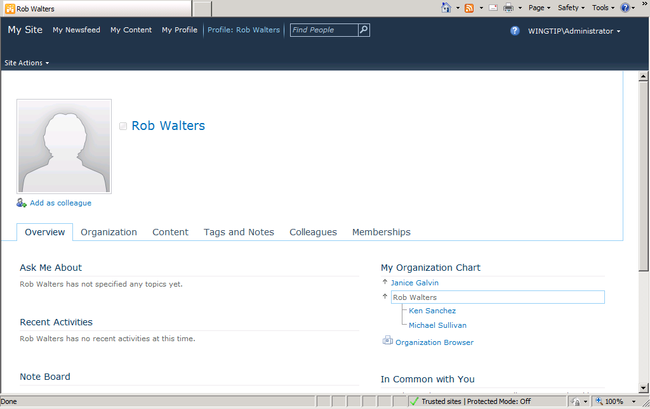

1. The first thing Rob will do from his profile page is to edit his profile. Click **My Profile** in the top navigation and then click the **Edit My Profile** link under Rob’s picture placeholder. Use the following information to update Rob’s profile:

**About Me:** I am an IT program manager, it is my duty to find innovative ways to use technology to our benefit.

**Picture:** upload the picture [[LAB FILES]]\StarterFiles\Rob.jpg

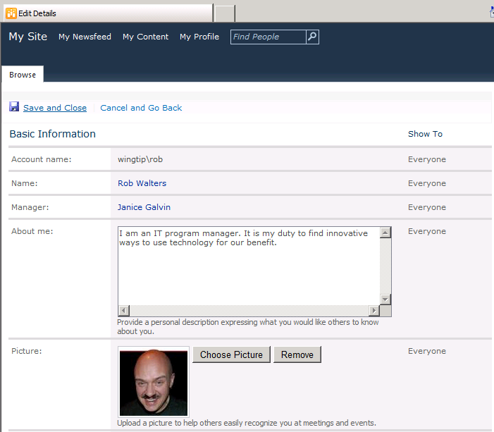

**Ask me about:** SharePoint, Infrastructure

**Skills:** Programming, Office 2010

**Interests:** Mountain Climbing, Chess

**Office location:** North Campus

**Time zone:** Pick Pacific Time using the drop down

**Mobile phone:** 555-321-5432

**Home phone:** 555-789-5678

1. For the drop down after **Home Phone** text box, select **My Manager** from the selections.
2. Click the **Save** **and** **Close** link at the bottom of the page to save the profile. The profile now shows up as it would to everybody.
3. Click the **More Information** link and the **Mobile Phone** should appear.
4. Rob’s **About Me** description also appears on the page. However, all other attributes are currently hidden.
5. Use the drop down on the top to change the **View My Profile** as seen by option to **My Manager**. Now click on the **More Information** link. The **Mobile Phone** as well as **Home Phone** should both be visible to the manager.

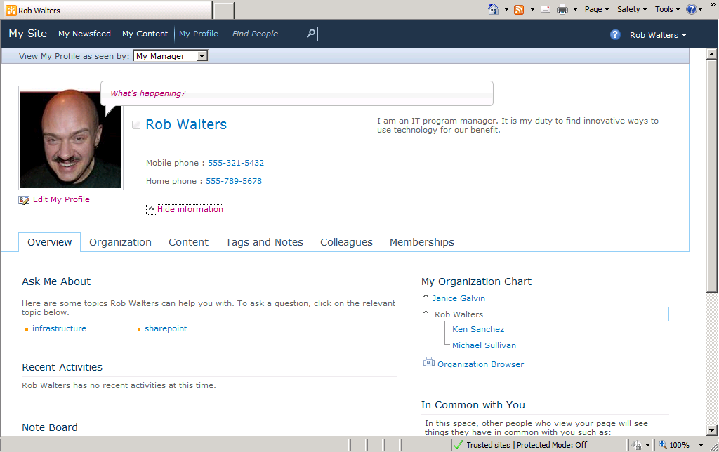

1. The **My Profile** page shows six tabs. Select the **Overview** tab. In the Overview tab, you see Rob’s skills listed below under the **Ask Me About**. Also there is a **Note Board**.
2. Type in the following post in the **Note Board**: **Ask me any questions you have about our company infrastructure by posting a note in this Note Board.**
3. Click the **Post** button. The post should appear now and Rob has the facility to edit or delete this post.
4. On the right hand of this page, you should also see the **My Organization** chart. It shows that Rob Walters has two direct reports, Ken Sanchez and Michael Sullivan; also that Rob Walters reports to Janice Galvin.
5. To see a more visual depiction of this organization, click on the **Organization browser** link. The Organization browser will open showing Janice Galvin is the person that Rob Walters reports to and then Ken Sanchez and Michael Sullivan are Rob’s direct reports.
6. Click on **Ken Sanchez**. The Organization browser should expand to now show Ken Sanchez and show Michael Sullivan on the side, and Rob Walters at the top. This is a Silverlight driven view of the organization.

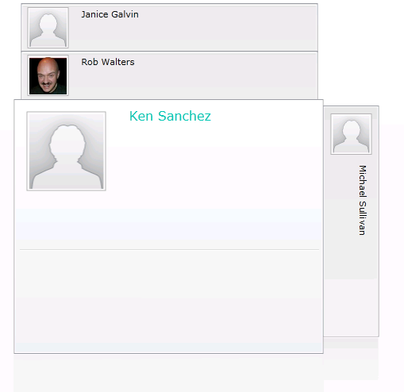

1. Feel free to click on different persons to see how the organization browser shifts and changes.
2. Click the **HTML view** link right in the lower-left corner of the page. It should now show the HTML view of organization. If Silverlight is not installed on the user’s computer, this would be their only option.
3. Click the **Colleagues** link. The Colleagues tab should show Janice, Ken and Michael as the three colleagues for Rob.
4. You will now switch the grouping of Ken and Michael. Click the **checkboxes** beside **Ken** and **Michael**, click on **Edit Colleagues** link.
5. From the **Edit Colleagues** dialog box that appears, click on the **New Group** radio button in the **Add to Group** section and type in **Direct Reports** in the text box. Click the **OK** button.

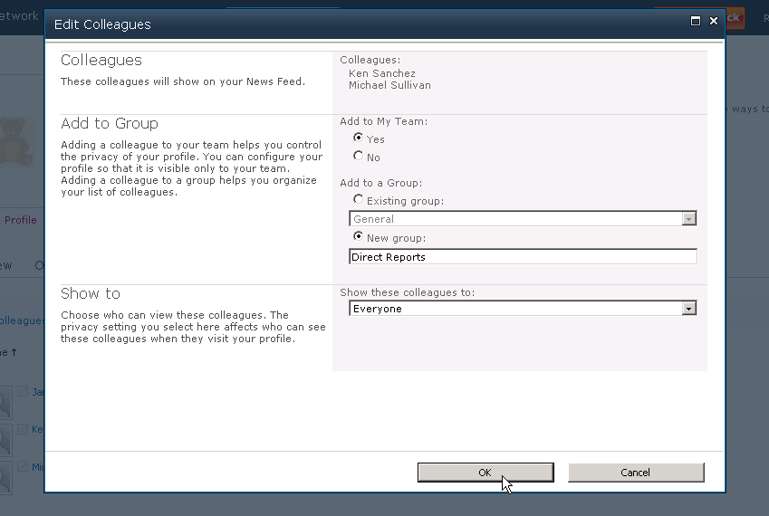

1. Ken and Michael should now be grouped under Direct Reports grouping.
2. Click the **My Content** link at the top left of this page. Since this is the first time that Rob is going to the My Content section of this site, it will now create that section in the Default Lists and Libraries.
3. If a dialog box should come up asking if you want to configure **My Site from Microsoft Office**, click on the **Yes** button.
4. Three Web Parts are on this My Content page: **Shared Documents, Personal Documents and Recent Blog Posts**.

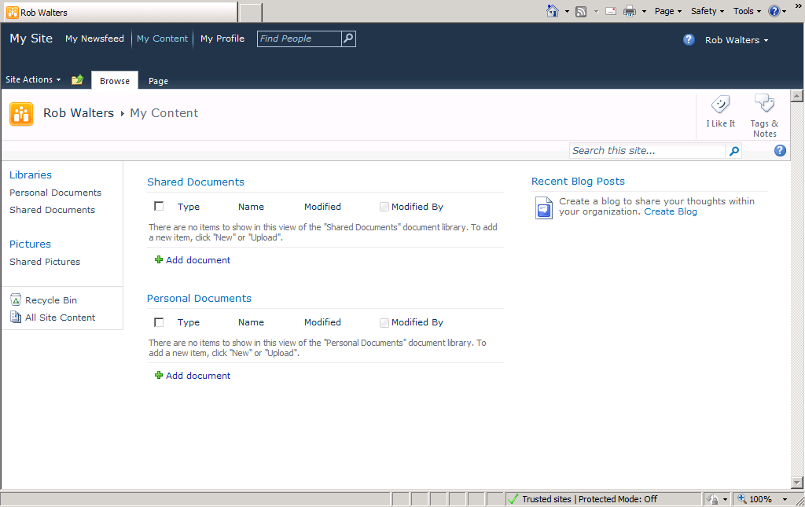

Shared Documents is the Web Part that Rob can use to share the documents with other people who come to his My Site. Personal Documents is the library that Rob would use to hold private documents in. And the Recent Blog Posts Web Part is where Rob can create his new blog underneath his My Site.

1. Click the **Create Blog** link. A new blog for Rob should now be created with the first sample entry stating **Welcome to your Blog**.
2. On the right of the page, under **Blog Tools**, click on **Create** a post. Use the following information to complete the form:

**Title:** My first entry

**Body:** I am excited to be blogging under my My Site!

1. Click the **Edit » Publish** button at the bottom of this dialog box, the new blog entry should now be visible on the page.
2. Click the **Folder** icon next to the **Site Actions** menu. This should show you that your current location is at the home page of the blog and Rob Walters’ My Site exists as a parent site.
3. Click on **Rob Walters.** You will now be navigated back to the **My Content** portion of the My Site showing the blog entries on the right of the page.
4. Navigate to the **My Profile** section of this page. Notice that there is a phrase **What’s happening?** that exists right by Rob Walters’ image. Click on it and type in the following – **Enjoying configuring my My Site**. This is the microblogging feature that My Site provides to update your status and inform other people.
5. Sign in to this page as **Ken Sanchez**. It should now show you Ken Sanchez’s My Site.

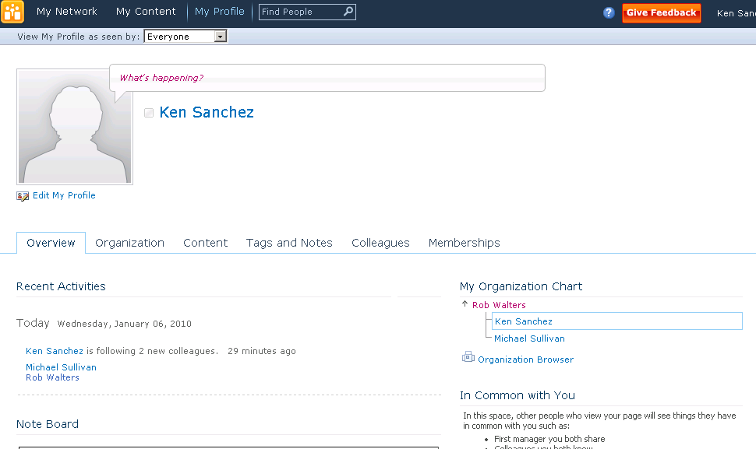

1. Click on **Rob Walters** in the **My Organization** chart. Since Ken reports to Rob, Rob’s name appears on his page. At this point in time, Ken Sanchez is looking at Rob Walters’ My Site.
2. Click the **More Information** link, notice only that Mobile Phone is available for Ken Sanchez to see. Also the links to edit the profile and other personal links that Rob has do not appear to Ken.

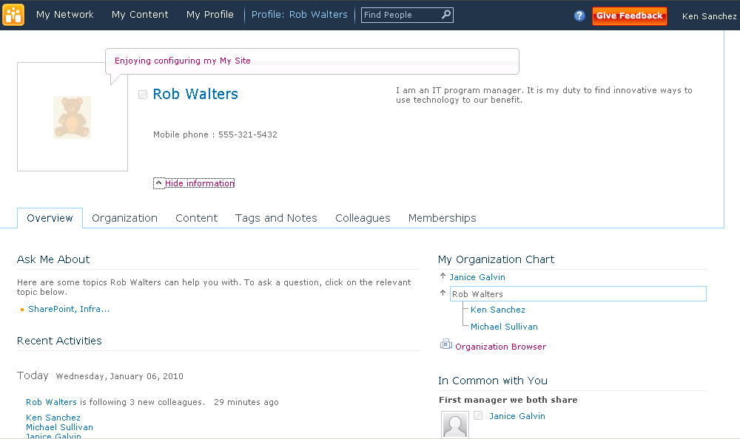

1. Click on **My Content** link. The My Content link goes ahead and starts creating a new site for Ken. Note that this My Content page looks exactly like what Rob started out with.
2. Click back on **My Profile** link. Click on **Rob Walters** link under **My Organization** chart. At the bottom of the page, you should see the note from Rob Walters. Type in a message in the Note Board as following: **I like what you have done with your My Site. I might need your help setting up mine.** Click the **Post** button.
3. A new post has now gone in the note board for Rob Walters.

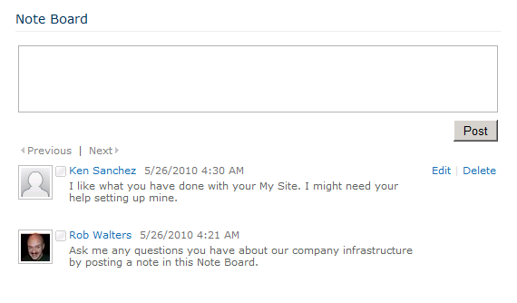

In this exercise you interacted with many of the My Site capabilities in SharePoint Server 2010.